VL-NF-1 LED Pin Fin High Bay Light

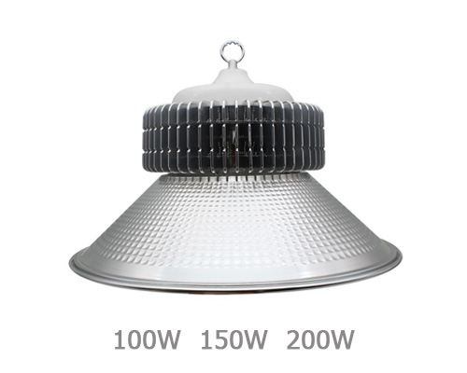
Power | Size
100W | Φ230 x H85mm
150W | Φ245 x H85mm
200W | Φ275 x H85mm

- Input Voltage: 90-300V with 440v Protection
- PF>0.95
- Luminous Efficiency: 100-130lm/w
Technical data:

Size | Φ230 x H85mm | Φ245 x H85mm | Φ275 x H85mm
Power | 100W | 150W | 200W
Luminous(LM) | 12000LM±100 | 18000LM±100 | 24000LM±100
Input Voltage | 90-300V | 90-300V | 90-300V
Color Temperature | 3000K-6500K | 3000K-6500K | 3000K-6500K
Power Factor | PF>0.95 | PF>0.95 | PF>0.95
Reflector Size | 120°, Φ500mm | 120°, Φ500mm | 120°, Φ500mm
Warranty | 3 Years | 3 Years | 3 Years
Working Temperature | -20℃～65℃ | -20℃～65℃ | -20℃～65℃

FEATURES:
IP65
110-130LM/W
Leading edge LED chip technology
Patent for LED high bay Luminary LEDs
V-Light 50W driver

VL-NF-2 LED Pin Fin High Bay Light

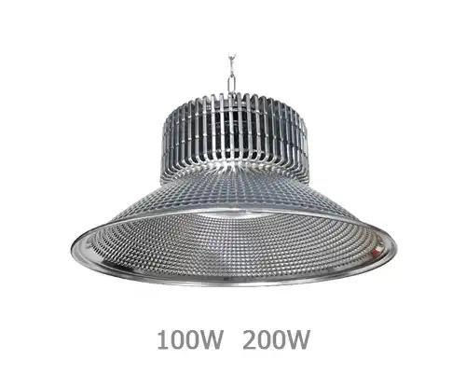
Power | Size
100W | Φ220 x H85mm
200W | Φ260 x H85mm

- Input Voltage: 90-300V with 440V Protection
- PF>0.95
- Luminous Efficiency: 120-130lm/w

Technical data:

Size | Φ220 x H85mm | Φ260 x H85mm
Power | 100W | 200W
Luminous(LM) | 12000LM±100 | 24000LM±100
Input Voltage | 90-300V | 90-300V
Color Temperature | 3000K-6500K | 3000K-6500K
Power Factor | PF>0.95 | PF>0.95
Reflector Size | 120°, Φ500mm | 120°, Φ500mm
Warranty | 3 Years | 3 Years
Working Temperature | -20℃～65℃ | -20℃～65℃

Features:
IP65
120-130LM/W
Leading edge LED chip technology
Patent for LED high bay Luminary LEDs
V-Light 50W driver

VOC-NF-3 LED Pin Fin High Bay Light

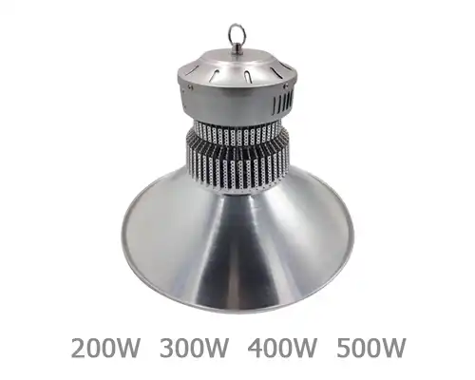
Power | Size
100W | Φ198 x H100mm
150W | Φ205 x H115mm
- Input Voltage: 90-300V with 440V Protection
- PF>0.95
- Luminous Efficiency: 120-130lm/w

Technical data:

Size | Φ198 x H100mm | Φ205 x H115mm
Power | 100W | 150W
Luminous(LM) | 12000LM±100 | 18000LM±100
Input Voltage | 90-300V | 90-300V
Color Temperature | 3000K-6500K | 3000K-6500K
Power Factor | PF>0.95 | PF>0.95
Reflector Size | 120°, Φ430mm | 120°, Φ430mm
Warranty | 3 Years | 3 Years
Working Temperature | -20℃～65℃ | -20℃～65℃

Features:
IP65
120-130LM/W
Leading edge LED chip technology
Patent for LED High Bay Luminary LEDs
V-Light 50W driver

